Revealed preference theory
Revealed preference theory is attributable to Paul Samuelson in his article “Consumption Theory in Terms of Revealed Preference”, 1948. Consumer theory depends on the existence of preferences which materialise into utility functions. These utility functions are maximised by consumers subject to a budget restraint. The issue is that it is difficult to accept that individuals really have a definite mathematical formula in mind when choosing between different options. What revealed preference theory does is work backwards to assume that we can deduce these utility functions from consumer behaviour. Analysing these choices leads us backwards to a set of preferences that influences the choices they make. It therefore allows economists to study consumer behaviour empirically.
There are two main axioms to the theory, both based on completeness and transitivity:
WARP (Weak Axiom of Revealed Preference): If A is revealed preferred to B (A RP B), then it must be so in every case. That is, if a consumer ever chooses B, then we must assume that A was previously chosen and that the budget constraint had enough ‘left over’ to allow a consumer to choose B as well.
SARP (Strong Axiom of Revealed Preference): This adds transitivity. If there are only two goods, then it is clear that WARP already defines a consumer’s choice: A over B. However, the SARP adds the idea of indirectly revealing preferences: if A is chosen over B and B over C, SARP and transitivity dictate that A is also preferred to C, so A is indirectly revealed to be preferable to C (A R* C). This drastically reduces the amount of empirical evidence necessary to define consumer preferences.
In the case shown in the figure below, we know that C is indirectly preferred to B (C R* B) because it allows us to reach a higher utility curve. Because C and B define a space (R*), and we know that C, B and A are contained within R*(R*{(C,B)}), then we can say that C RP A RP B, that is, by knowing from observation that C is indirectly preferred to B, we can tell that C is revealed as preferable to A (C RP A) and that A is revealed as preferable to B (A RP B).
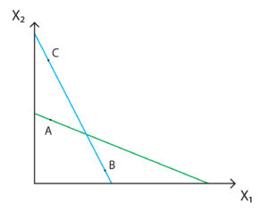
If we think of A, B and C as infinitely complex bundles of goods, we can map out all a consumer’s choices. In theory, we can track this backwards to actually build utility functions if we have access to unlimited data. Without actually having to do this, we can aggregate consumer data to reveal general truths about a certain population’s preferences.

